Fordham Institute ESSA Accountability System Design Submission

Authors:
Samantha Semrow
Austin Reid
Shannon Hossinger
Aliya Pilchen
Peter Weiss
Krista Kaput
Rebecca Ryan
Will Candell
Jocelyn McDaniel

Section 1: Introduction and Design Principles
Our accountability system was created with two primary goals in mind: 1) to pinpoint critical areas in which State Education Agencies (SEAs) could support schools and 2) to disseminate information to the public for accountability and selection purposes. In designing our system, we wanted to create a holistic assessment of school quality reflecting our recent experiences as educators in high-need schools, while upholding the importance of academic measures as the clearest metric to highlight educational inequity. We wanted to ensure that all schools are evaluated by the same academic indicators, while also acknowledging that schools have different populations with diverse needs. To this end, we favored a weighting system that adjusts first based on a school’s English Learner (EL) population, and then based on their varying levels of achievement and growth.

Since there are many ways to evaluate school quality, we included metrics that acknowledge major elementary school stakeholders and ensure that any one aspect of quality is not over-weighted. As SEAs already face significant capacity issues, we were reluctant to include any additional school quality metrics that we felt an SEA could not readily support. Additionally, we avoided metrics that lack a substantial research backing or those that capture factors beyond what the metric was intended to indicate. Generally, we aimed to limit the weight given to non-academic factors in order to have a more closely linked comparison with the accountability systems under NCLB.

Given that the system is meant to support, and not necessarily judge, schools, our holistic assessment of schools is communicated through descriptive labels, while still providing numeric ratings for some subcomponents so that the public will understand how their schools performed in those areas. We also included school quality factors that would be rated, but not included in a school’s final score. These descriptive factors are potentially useful in assessing school quality, but lack sufficient validity, reliability, and/or political support to be used to calculate school ratings. If these measures gain support and/or prove valid over time, the state evaluation system can adjust accordingly.
Section 2: Academic Achievement Indicators (67% of total evaluation)

2.A. English Learners (0-19.5% of total evaluation)
To close achievement gaps and measure English proficiency amongst English Learners (ELs), a state determined test will be administered as an entrance and exit assessment of non-native English speaking students. Students will be tested yearly and reclassified over time according to their assessment scores to measure progress towards achieving English proficiency. Entrance and exit criteria will be determined by the individual assessment and students will be phased into regular English instruction after reaching an appropriate level of English proficiency.

In our system, the proportion of EL students in a school will determine the weight given to English proficiency scores. English proficiency scores contribute a larger proportion of a school’s overall rating in schools with large EL populations. The remaining academic indicators of Annual Testing and Growth will then adjust appropriately in response. The breakdown is as follows:

20.01–100% = 19.5%
7.01-20% = 13%
2.01-7% = 6.5%
0.1-2% = 3.25%
0% or n ≤ 10 = 0%

For example, if a school’s EL population accounts for 16% of their overall student population, EL student test scores on the English proficiency exam will contribute 13% to their overall rating. Annual testing and growth factors would then adjust to account for 54% of the overall evaluation.

2.B. Annual Testing (10-57.5% of total evaluation)
Academic achievement is evaluated based on a state-designated annual assessment in reading and math for students in grades 3-5. The state would report the average reading and math scores for students in each grade, and then use those averages to generate percentile ranks for each school to order them from lowest to highest average scores for each grade in each subject. The median percentile ranks in reading and math for each grade would be used as an overall percentile rank for the school. The state would also report the average scores and percentile ranks for students in a variety of subgroups (including White, Black, Hispanic, Asian, Native/Pacific Islander, students eligible for free/reduced price lunch, English Learners, Former English Learners, and students with disabilities). The state would also report the percentage of students who achieved proficiency on the state-designated assessments, but those percentages would not be used for accountability purposes.

2.C. Growth (10-57.5% of total evaluation).
Student growth is evaluated using a student growth percentile (SGP) model, similar to the system currently used in Massachusetts and Washington State. This system describes a student’s score in the current year as compared to other students with similar test score histories. The median SGP of students in the school would be used as the overall percentile rank for the school. The median SGP for students in each of the subgroups listed above would also be reported.

The relative weighting of achievement and growth will vary according to a sliding scale, after the weight assigned to ELL English proficiency scores is determined. Growth is given more weight in lower performing schools, and less weight in schools with higher levels of academic achievement. Regardless, both growth and academic achievement will count for at least 10% of the overall score. For example, for a school with no ELL students in the lowest academic achievement percentile, their academic achievement will count as 10% of the overall score and their median SGP will count for 57%. Similarly, for the school in the highest academic achievement percentile, their median SGP will still count for 10% of their overall score and their academic achievement will count for 57%. If either school had an ELL population, the weights for achievement or growth would be reduced, but still maintaining a weight of at least 10% for each indicator. A visual of the sliding scale is provided below:

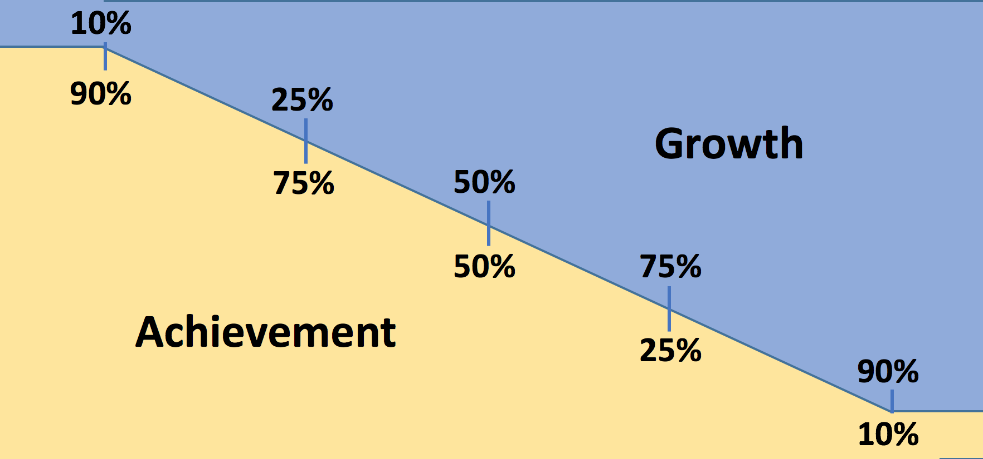

The points assigned in our accountability system would be based on a combination of the overall percentiles in academic achievement and growth, and also the percentiles for the student subgroups listed above.

The aggregate score for achievement and growth categories will be the combined total of the subgroups described above. Depending on state achievement gap priorities, some subgroups scores should be given greater weight than others. If subgroup populations are similar in most schools across the state, the state may choose to apply the same weights to all schools. However, if demographics vary greatly across schools and districts, the state should have to option to modify weights for select schools and districts.

Section 3: School Quality and Student Success Indicators (33% of total evaluation)

3.A. Parent/Family Indicators (11% of total evaluation)
Family engagement is a vital component of student success that is often overlooked in school evaluation. Family engagement studies consistently find that higher levels of parental involvement are associated with higher student achievement outcomes and that parent involvement programs at the school level work at increasing parental involvement. Including this as an indicator serves several goals: 1.) promotes increased efforts by schools to reach out to and interact with parents, thereby increasing parental involvement with schools 2.) creates channels of communication between home and school and 3.) provides schools with context around opportunities for growth. We favor awarding points based on a continuous scale to credit schools for incremental improvements, rather than allowing for unintended consequences associated with cutoffs.

Family Survey Completion Percentage (5.5% of total evaluation)
If too few families respond to a survey, the results lack validity and reliability. For this reason, schools will be scored on their survey completion percentage. This will provide for more accurate information and will incentivize schools to increase their efforts at parent outreach and engagement.

- Family survey completion percentage multiplied by 5.5% = total points toward overall score

Family Engagement and Satisfaction Survey (5.5% of total evaluation)
A Family Engagement and Satisfaction Survey will assess parents’ thoughts on the climate of a school and the school's efforts to involve them. In this way, survey data will provide necessary information on how schools can improve. Average scores will be calculated and compared to all district and state elementary schools.

- Average family engagement/satisfaction score multiplied by 5.5% = total points toward overall score

3.B. Staff Indicators (11% of total evaluation)

Teacher Retention (4% of total evaluation)
Teacher retention is a measure of school success due to its proven ties to student achievement outcomes and community engagement. Using teacher retention as a measure for school quality can also shed light on the working conditions that are in the school that may be impacting student achievement. Schools will only be scored based on the percent of teachers retained who were invited back so as not to disincentivize the removal of low-performing educators.

- Percent of teachers retained (those who were invited back and chose to return) multiplied by 4% = total points toward overall score

Teacher Attendance (7% of total evaluation)
Student achievement is adversely impacted when teachers are absent for 10 or more days. Furthermore, the cost of teacher absenteeism to districts is significant. Using teacher attendance as a measure of school quality can relay information about the school’s working environment for teachers, which has significant impact on student achievement and school quality.

- Teacher attendance rate multiplied by 7% = total points toward overall score

Teacher and Administrator Surveys (reported but not included in overall score)
Using an Administrator and Teacher Survey as a measure of school quality can convey information about the school climate and working environment from the perspective of teachers, principals and assistant principals. These scores will not be included in overall accountability scores to prevent any perverse incentives for schools to manipulate responses.

Average Teacher Evaluation Score (reported but not included in overall score)
The state will track the average teacher evaluation score for each school each year. This allows for a comparison of teachers across schools, as research has long indicated that teacher quality is an important contributing factor to student success. This number will not be included in the overall score because of concerns about the validity and reliability of these measures, and because teacher quality is captured by the student achievement and growth measures described above.

3.C. Student Indicators (11% of total evaluation)

Average Daily Student Attendance (10% of total evaluation, divided evenly across grades K-5)
Attendance in the early grades is critical in sustaining and building on academic achievement.Chronic absence in the early grades also reflects how well schools are addressing the needs of students.

- Student attendance rate multiplied by 10% = total points toward overall score

Student Attrition (1% of total evaluation)
Several studies illustrate that students who remain in the same school perform better on standardized tests than students who transfer schools. Achievement suffers when families and students move frequently, and increased migration rates for disadvantaged and minority families have been suggested as a possible factor in causing achievement gaps. This indicator will initially be considered as a small percentage of a school’s overall evaluation score until state officials can ensure accurate reporting, and so as not to penalize schools with high transient populations.

- Student retention rate multiplied by 1% = total points toward overall score

3.D. General School Quality Indicators (reported but not included in overall score)
The following indicators will be tracked but not scored in the initial implementation year(s). They contribute to a comprehensive school overview and may serve to alleviate the potentially negative consequences associated with an overemphasis on standardized testing:

- Expulsion/Suspension Rates - compared to district and state averages and reported by subgroups
- Minutes of Arts/Physical Education/Recess - average minutes spent in each subject per week is tracked by grade level and compared to district/state averages
- Ratio of Students to Support Staff (counselors/social workers/psychologists) - smaller ratio of students to support staff is associated with fewer discipline issues and demonstrates a school’s commitment to student well-being

Appendix A. Flow Chart of Accountability System

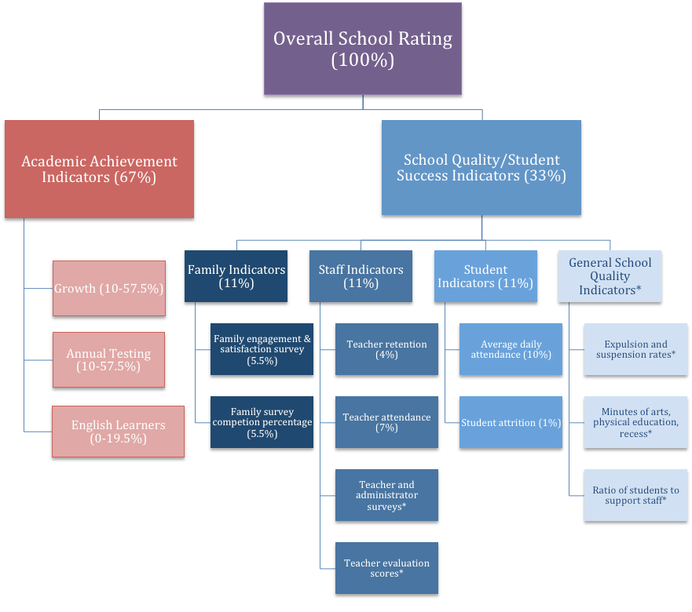

*Several indicators are reported by not included in the overall score in the first year(s) of implementation due to limited research on validity and reliability of measures, and mixed political support.

http://www.hfrp.org/publications-resources/browse-our-publications/parental-involvement-and-student-ac hievement-a-meta-analysis
NBER
http://www.attendanceworks.org/research/elementary-school-absenteeism/
http://www.ibo.nyc.ny.us/iboreports/2014attritioncharterpublic.html
http://www.pewtrusts.org/en/research-and-analysis/reports/2008/12/16/the-hidden-costs-of-the-housing- crisis-the-longterm-impact-of-housing-affordability-and-quality-on-young-childrens-odds-of-success
http://www.schoolcounselor-ca.org/files/Advocacy/Lower%20Counselor%20Ratios%20Equal%20Less% 20Discipline.pdf

