School Accountability Begins With Families
Accountability Under ESSA Design Competition
by Alex Hernandez

My twin boys start middle school next year and our family spent the last ninety days researching seven schools in Boulder Valley School District (BVSD) in Colorado - four traditional public schools, one district choice school and two charter schools. BVSD has an open enrollment system where students can enter a lottery to attend a school that is not their assigned neighborhood school.

While the seven schools differ in many respects, each school claims to 1) have the very best teachers and 2) individualize their programs for every child’s unique needs. One of my nine-year-olds sympathetically noted, “I think [every school] has to say that.”

Judging the relative effectiveness of different schools with dramatically different programs was difficult, if not impossible. Three schools briefly referenced their state test scores, mostly because the scores were high. One school dismissed the value of state test results altogether but did not offer any alternative evidence of student achievement or growth.

As an experienced educator, I took the highly scientific approach of gathering anecdotes from families in my social network who had children enrolled at these schools. I also eyeballed standardized test scores which seemed to be highly correlated with student demographics.

My family entered the school choice lottery based more on gut feel than actual evidence, even after attending roughly two dozen enrollment meetings and school tours. I learned that schools are frustratingly opaque to the conscientious family trying to find the best school for their children.

I began to wonder, what would it look like to provide families with clear, useful information to help them understand school quality? The Every Student Succeeds Act gives flexibility to states to reboot and design new school accountability systems so families can better evaluate schools for their children.

Design Objectives

Our proposed accountability framework is geared towards helping families answer three basic questions about a school:

- Will my child enjoy and thrive in this school? (LOVE)
- Will my child get what she needs to grow academically from whatever place she is starting? (GROWTH)
- How is my child doing academically? (ACHIEVEMENT)

When families discuss schools, the first question is almost always some version of “does Jenny like XXX school” or is “Jenny happy there?” Curiously, policy-makers rarely seem to pose such questions, creating an immediate disconnect between regulators and the actual families attending public schools.

The proposed accountability framework envisions a world where families have clear, actionable information designed to answer questions they ask in the real world. The hypothesis is this data will also provide the fodder families need to advocate for change in their existing schools and/or vote with their feet by moving to new schools.

For schools traditionally considered low-performing, the proposed framework provides additional nuance around student satisfaction, well-being and academic growth to provide a more robust view of school quality beyond basic proficiency measures.

For schools traditionally considered high-performing, the framework may reveal areas for improvement that were not obvious in the past, unleashing new energy for better schools in more affluent areas.

Instead of earning a single letter grade, schools can earn a badge in each of the three areas: LOVE, GROWTH and ACHIEVEMENT. Letter grades are appealing in their simplicity, but different combinations of badges can provide important nuances about schools and help families tell more complex narratives.

For example, a school that earns an Achievement badge but not a Growth or Love badge means that students enter the school performing at high level and stay there. But students do not actually grow very much academically nor do they enjoy attending the school. Conversely, a school that earns a Love badge but not a Growth or Achievement badge means the students adore the school but are not growing or achieving academically.
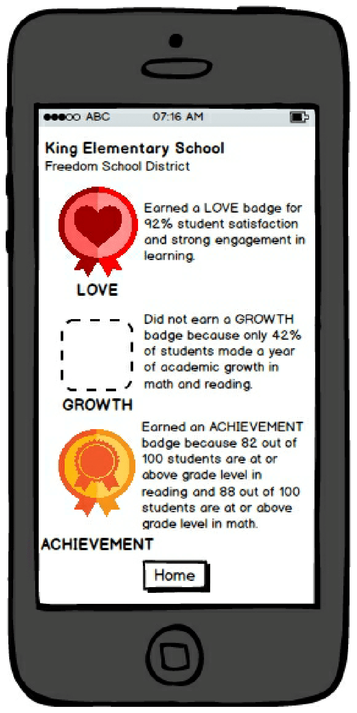
Let us dig into the three badge areas.
Indicators of Academic Achievement

The Love measure is intended to answer the question, do students love their school? We believe student perception surveys can attempt to gauge student satisfaction, well-being, engagement and connectedness, similar to how they have been used to judge teacher effectiveness in the Bill & Melinda Gates Foundation Measures of Effective Teaching (MET) Project.

Illustrative survey questions include:

- I look forward to going to school on most days.
- I am learning a lot from my teachers this year.
- There is an adult at my school who cares about me.
- I feel connected to my classmates.
- I feel physically safe at school.
- I can be happy, sad, angry or frustrated at school and the adults care about how I feel.
- I have read a book that I love in the last 30 days.

[Note: These questions are illustrative. Survey experts can modify the questions to make them valid and reliable.]

Surveys can be administered via organizations like Panorama or Tripod and completed in less than 30 minutes in grades 2-5.

We contemplated including measures of educator engagement, but most families assume that their teachers are “good” and providing data to the contrary is an uphill, politically charged battle. We opted to provide more granular student level data to put pressure on schools and adults.

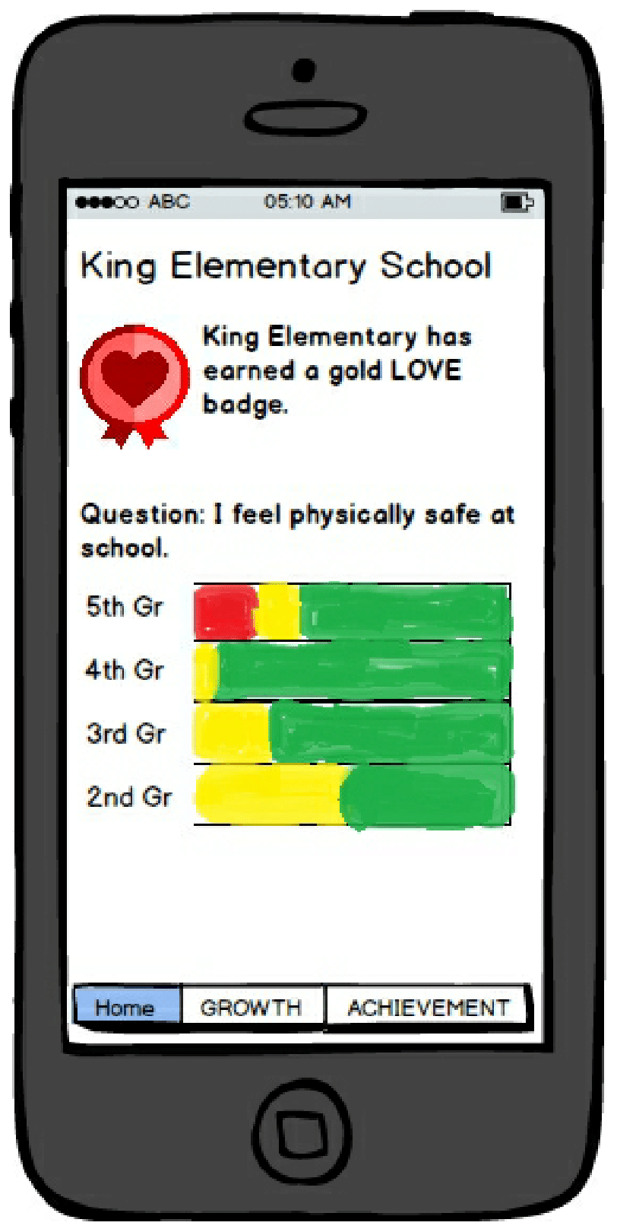
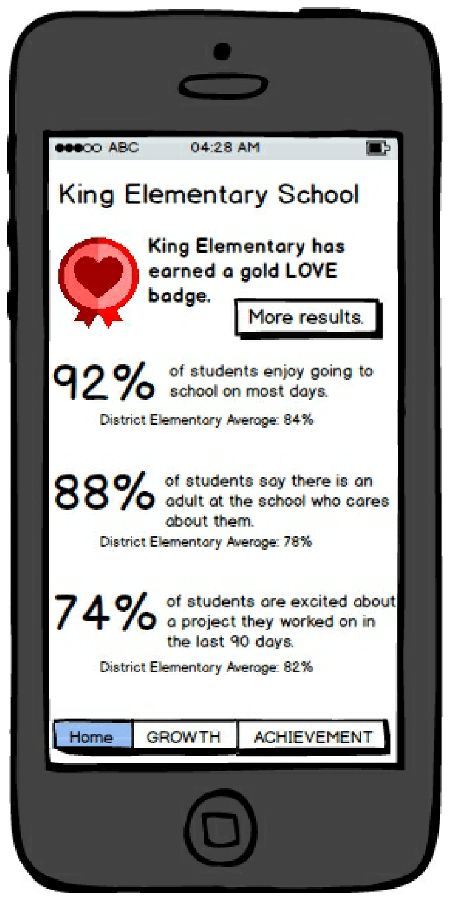

The approach to Achievement is perhaps the largest departure from traditional accountability systems of the past. Historically, K12 state standardized tests measure student understanding of specific academic standards (e.g., a 4th grader can recognize equivalent fractions) and determine in a binary way whether students are proficient or not on that grade level standard. In other words, there is a fixed performance bar and a student is somewhere relative to that fixed bar.

For students who are not proficient, proficiency-based tests are not good at conveying whether a student is 2 months behind or 2 years behind - which is critical information for families. On the flip side, if a third-grader is advanced on third grade standards, the natural question is how would that student do on fourth or fifth grade standards which a proficiency-based test also doesn’t answer.

The proposal is to shift to an adaptive assessment that measures student progress across a continuum of grade levels in math and literacy. So, for example, Jose is an eight-year-old, third-grader and his family is informed that he is proficient at a fourth grade level in math and a second-grade level in reading.

In addition to saying Jose does math at a fourth-grade level, the accountability framework should also provide comparative data such as, “Jose performs at a higher level than 72% of other students his age.” This is how pediatric data such as weight and height are presented to families.

By weakening the relationship between a student’s age and grade-level content, the framework may be more suitable for accommodating future students who learn in competency-based academic programs.

For federal purposes, states can crosswalk their data into proficiency buckets and satisfy regulators.
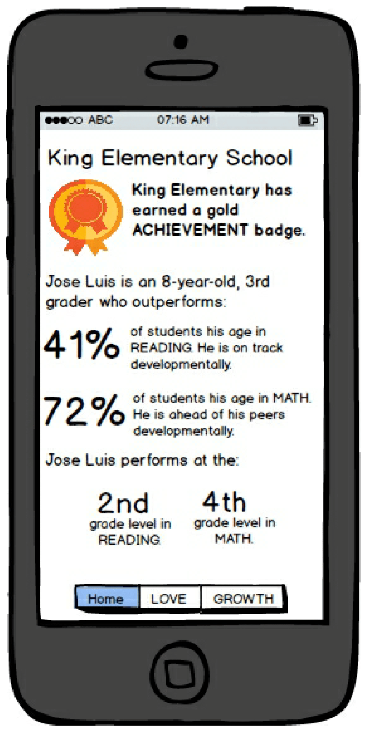

The Growth measure assesses how much academic progress each individual student makes, regardless of her starting point.

Schools can help low-performing students make significant growth, but under NCLB, schools were largely not rewarded for such progress if students never became proficient. In wealthier neighborhoods, where many students entered the school year as proficient, it remained difficult to judge how much value, if any, schools were adding.

Of course, we want all to students to march towards grade level proficiency, at a minimum, but juxtaposing growth with achievement is a better approach than proficiency on its own.

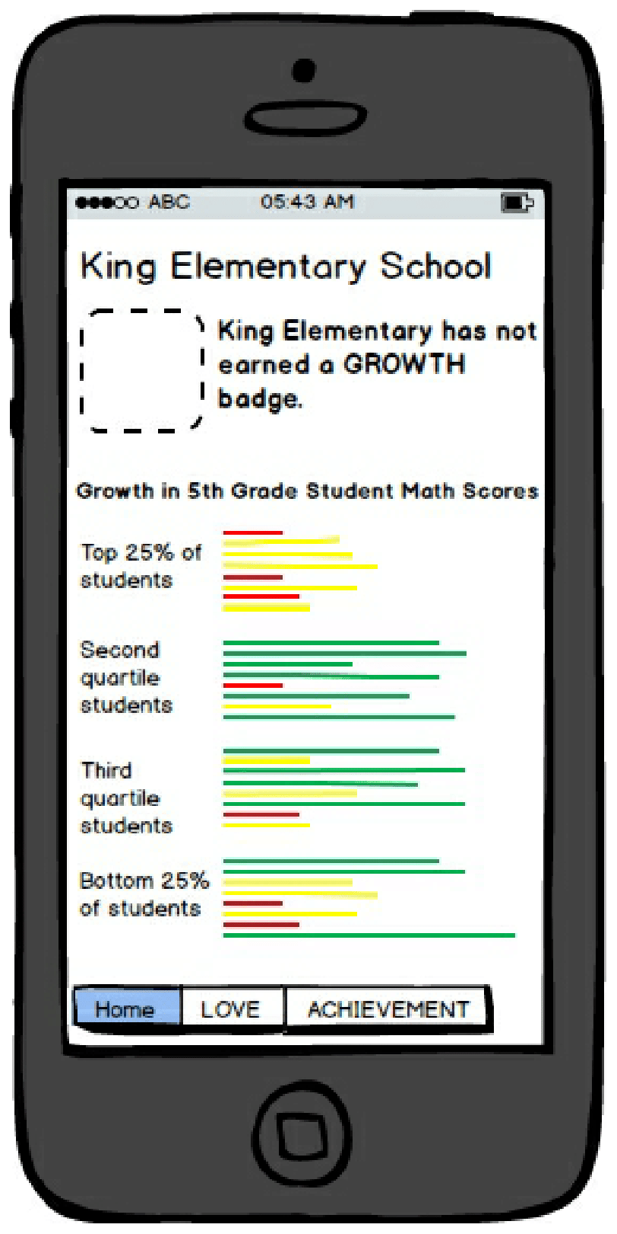

The proposed growth model focuses solely on math and reading in elementary grades 2-5. The design team was tempted to capture measures of inputs and/or outputs associated with a rich, content-based curriculum which we believe is critical to elementary school success and prerequisite for schools that hope to do well on Common Core assessments. However, we could not figure out how to effectively measure extended engagement with rich content so we opted to include proxy questions in the student survey as a hack.

The framework proposes using the same set of Achievement and Growth measures to assess English Language Learners and potentially other subgroups like Special Education students but to not include their results for accountability purposes until they have been in the school system for two years.

Identifying Low-Performing Schools

Instead of a summative school grade which can be opaque to families and hard to decipher, the proposal envisions that schools are eligible to earn up to three badges: Love, Growth and Achievement. Each badge has a bronze, silver and gold status to differentiate performance levels.

Initially, low-performing schools would consist of those schools that did not earn any badges or earned one or two bronze badges.

This means schools with large populations of low-performing subgroups would not necessarily be sanctioned if they earned Love and Growth badges but not Achievement badges, which makes this proposal a weak form of the growth-to-proficiency model.

On the other hand, it provides opportunities to show areas of improvement across a wider variety of schools and pays attention to students (e.g., middle-class students, academically advanced students) that were largely ignored in the previous accountability system.

This tradeoff will put off reformers who believe that the primary purpose of school accountability systems is to improve schools in low-income neighborhoods. We agree that equity in education should be one of the top priorities and draw a disproportionate share of our time and energy, however, education reform should not be something that only happens in some neighborhoods. This proposal is one path to engage the broader US citizenry around quality schools, moving the conversation from some kids to all kids.

The truth is, designing the perfect accountability framework is probably less important than the quality and granularity of information we put in the hands of families. We need fewer policy wonks and more design thinkers who can empower families and communities with the information they need to support their children.

